1. Semantics - Navigating content - Intro
2. Navigating with a screen reader

Voiceover = favorite screen reader. Built into Mac OSX. Cmd F5.

Wikipedia has a lot of links…

Level of the heading indicates how prominent a heading is.

1. Navigating by Headings
2. Using Headings

DOM order matters for layout and screen reader.

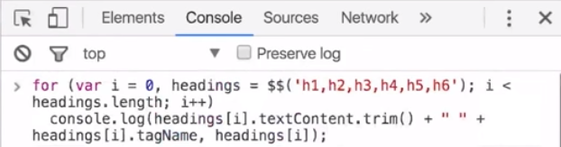

1. Quiz: Using Headings
2. Other navigational options
3. Other navigational options example

Search access key available: f on Wikipedia. Do not spell things phonetically just to make things sounds better on a screen reader.

1. Link Text

The purpose of each link should be able to be determined from link text alone. Learn more about responsive layout is better than just “learn more”.

1. Quiz: Link Text
2. Landmarks

HTML 5 introduced landmarks like main, header, footer, nav, article, aside, and section; allow screen readers more ability to quickly navigate a page.

1. Quiz: Landmarks
2. Outro Lesson 4

Use meaningful headings and link text. Do not try to control the screen reader’s experience.